**6. Stars evolve and eventually 'die'**

***Describe the processes involved in stellar formation***

* Stellar formation begins with the gravitational contraction of a vast nebula of interstellar dust and molecular gas (mainly hydrogen). If the mass of the nebula exceeds a certain level (Jeans mass), the gravitational force within it is greater than any thermal pressure outwards, causing the cloud to begin to coalesce. A growing core of matter at the centre forms.
* The increasing gravitational attraction of the core causes the contraction to accelerate. Several stars may form together by fragmentation of a very large nebula to form a cluster. The mass of the dust and gas in each contracting region determines the mass of the star that forms and, hence, where that star ultimately enters the main sequence of the Hertzsprung-Russell diagram.
* During contraction, gravitational potential energy is converted into thermal energy. The increasing pressure caused by the rising temperature begins to oppose the gravitational force within the nebula, slowing the contraction process. The contraction process can take from a hundred thousand years for a massive star to tens of millions of years for a small star.
* The core continues to contract until pressure and temperature builds up enough for nuclear reactions (i.e. hydrogen fusion) to start. A balance then occurs between gravity directed inwards and the pressure of radiation outwards (from the hydrogen fusion in the core), preventing any further collapse.
* Radiation and stellar wind are emitted from the star. They push away remaining gas and dust that would have fallen into the star. The star continues to emit radiation in a stable way for a long time to come.

***Outline the key stages in a star’s life in terms of the physical processes involved***

* As described above, material accumulating at the centre of a nebula collapses under the force of gravity. As a result, a core of hot and dense matter forms. Heat radiated from the core causes the surrounding cloud to become luminous. The luminous cloud with its hot, dense core is known as a **protostar**. The increasing density of the core begins to slow further in-falling of matter.
* Eventually the protostar reaches a temperature where molecular hydrogen breaks down to atomic hydrogen, allowing further compression and heating. When it reaches maximum luminosity, it is known as a **pre-main sequence star**. From then, it continues to shrink, becoming hotter but less luminous.
* 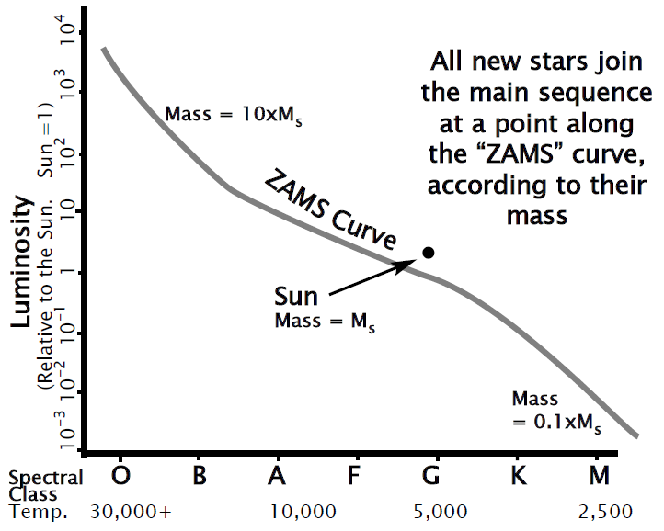A star becomes a **main sequence star** when temperature and pressure are high enough for nuclear fusion to begin and make the star shine. There is an equilibrium (i.e. a balance) between gravity pulling inwards and energy (released by fusion) pushing outwards, preventing any further gravitational contraction. Remnant dust and gas not accreted into the core are removed by the stellar wind. The star now has a distinct surface.
* The star now lies on the line of the main sequence, where it remains for about *90% of its lifetime*, steadily converting hydrogen into helium by nuclear fusion in its inner core. Exactly where the star joins the main sequence depends entirely on its *mass* – stars of higher mass will join higher up the Main Sequence. During its time on the Main Sequence, the star becomes hotter and more luminous. Massive stars consume their fuel at a faster rate, while smaller stars burn their fuel more slowly and therefore spend a longer time on the main sequence.
  + TLDR = the larger the star, the faster it burns its fuel and the shorter its time on the main sequence
    - But why do larger stars burn their fuel faster? It is because stars of higher mass will have a greater gravitational force and this then requires a greater rate of nuclear reactions to produce adequate pressure outwards to oppose the force of gravity inwards.
* When the helium content in the core is around *12%*, fusion of hydrogen stops, and the star moves off the main sequence to become a **post-main sequence star**. Without the energy of hydrogen fusion, the core of the star collapses and, hence, temperature rises further. With this increase in temperature and pressure, the helium in the core then begins to fuse to form heavier elements. The outer layers of the star are now pushed out and begin to cool. The star becomes a **red giant or supergiant**.
* A star’s life ends when it runs out of fuel, that is, when fusion of lighter elements into heavier elements in the core ceases and the star collapses under its own gravity. Depending on the star’s mass, it will become either a white dwarf, neutron star / pulsar, or a black hole.

***Describe the types of nuclear reactions involved in Main-Sequence and post-Main Sequence stars***

* Main-sequence stars are ones that, when plotted on an H-R diagram, lie within a band stretching from the upper left to the lower right. It is believed that, due to the relationship between mass and luminosity, main-sequence stars have a common energy source – the nuclear fusion of hydrogen nuclei into helium nuclei. (Note – a hydrogen nucleus is simply a proton)
* There are two ways in which hydrogen is fused into helium in stars. They are discussed below:

*The Proton-Proton (PP) Chain*

* The proton-proton (PP) chain is the predominant type of nuclear reaction in lower mass, cooler main-sequence stars (i.e. under about 20 million Kelvin). It converts hydrogen into helium in three steps:

1. Fusion of two hydrogen nuclei (i.e. two protons) to form a deuterium nucleus, since one of the protons transmutes into a neutron. This fusion process also involves the release of a positron and a neutrino.
2. Fusion of a proton and a deuterium nucleus to form a helium-3 nucleus. The fusion process also involves the release of gamma radiation.
3. Fusion of two helium-3 nuclei to form a helium-4 nucleus. This fusion process also involves the release of two protons, which may participate in further PP chain reactions.

* So, here is a summary of the process:

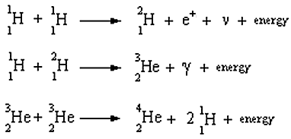

* The net result is that 4 protons have combined to form one helium nucleus. And here is the net equation:



* 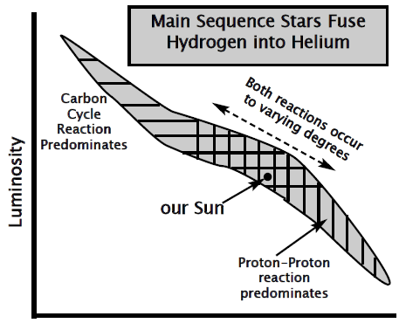Note – Even though six hydrogen nuclei are involved in the production of a helium nucleus, two of them are released. That is why the net equation for the process has 4 hydrogen nuclei as its reactants.
* A good fact to remember is that the PP chain accounts for 85% of hydrogen fusion in the Sun. The other 15% is accounted for by the CNO cycle. Read below…

*The Carbon-Nitrogen-Oxygen (CNO) Cycle*

* The carbon-nitrogen-oxygen (CNO) cycle is the predominant type of nuclear reaction in higher mass, hotter main-sequence stars. Like the PP chain, it converts 4 protons into 1 helium nucleus but does so by a different process.
* First of all, here is a summary of the process:

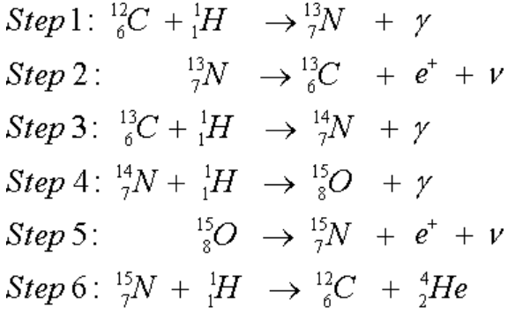

* Note, in the above diagram, the following symbols have the following meanings:
  + = gamma radiation
  + = positron
  + = neutrino
* So, we can see that four successive protons combine with a carbon nucleus to produce nitrogen first, then oxygen and finally carbon again plus a helium nucleus.
* In a sense, the process is cyclic, as a carbon nucleus is present both at the start and at the end, and can initiate the process again. As a result, carbon acts as a catalyst in the fusion of hydrogen into helium.
* Remember that the net equation for the CNO cycle is the same –4 protons have combined to form one helium nucleus. Again, here is the net equation:



*Post-Main Sequence Stars*

* In post-main sequence stars, most of the hydrogen fuel has been consumed and, as hydrogen runs low, energy produced by nuclear fusion significantly decreases. Therefore, gravity causes the star to collapse inwards and the temperature within the core skyrockets. However, helium is very plentiful in the core and, thus, a new fusion reaction begins – nuclear fusion of helium begins. This occurs as three helium nuclei can fuse to form a carbon nucleus through the triple-alpha reaction.

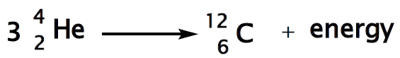

* 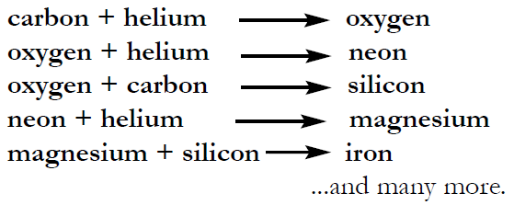Then, when the core is mainly carbon, contraction causes the temperature to rise further and helium fuses with carbon to produce oxygen. Further exothermic shell-burning nuclear fusion reactions may take place in successively deeper shells within the star, with elements such as oxygen, neon, silicon, magnesium and so on. The extent of these further fusion reactions varies from star to star, since it depends on the star’s mass.
* Note – In stars, nuclear fusion actually stops at iron. This is because once you get to iron, any fusion reactions require a net input of energy, and this is unsustainable. So that’s why iron is the limit.
* Note – The triple alpha reaction produces just 10% of the energy per kilogram of fuel compared with hydrogen fusion. Therefore, the fuel is used up so quickly, such that the time a star spends as a red giant may be just 10–20% of its duration as a main sequence star.

***Discuss the synthesis of elements in stars by fusion***

* Initially, only hydrogen and helium were present in the universe. All other elements have been synthesised by fusion during the life and death of stars. The mass of the star, and the stage of life of the star, determine which elements are produced.
* For more details, refer to the dot-point above.
* 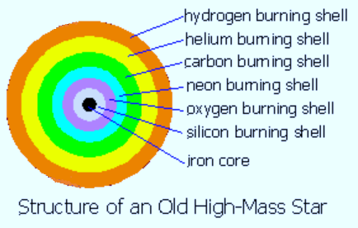Note – Elements beyond iron are able to be produced in two ways:
  + the slow capture of neutrons in a helium burning shell of a red giant can actually produce elements all the way up to lead, OR
  + the fast capture of neutrons in a supernova explosion provides enough energy to produce elements all the way up to uranium

***Explain how the age of a globular cluster can be determined from its zero-age main sequence plot for a H-R diagram***

* First of all what are clusters? Clusters are, simply put, groups of stars. There are two main types of star clusters:
  + globular clusters – tight groups of hundreds of thousands of very old stars which are gravitationally bound
    - are usually found in a practically symmetrical and spherical shape
  + open clusters – more loosely clustered groups of stars, generally contain fewer than a few hundred members, and are often very young
    - relatively close to us
    - all the stars with an open cluster were born from the same parent nebula
    - tend to take on the shape of their parent nebula
* Clusters do have the capacity to be destroyed, such as by a passing massive star whose gravitational field changes the motion of some of the cluster’s stars

*Now…*

* The H-R diagram for a cluster of stars with different masses, which have all just reached the main sequence, having just begun to consume hydrogen, is called the zero age main sequence (ZAMS) plot.
* When globular clusters are observed, it is found that the main sequence is missing the larger, more massive, blue stars. The more massive a star is, the more quickly it burns up its hydrogen fuel and moves off the main sequence into the red giant and supergiant regions of the H-R diagram. As a cluster ages, the H-R diagram for the globular cluster appears to ‘peel back’ from the main sequence.
* Therefore, of particular interest is the “turn-off point” which is the point where the graphical plot of the stars in a cluster leaves the main sequence and turn upwards to the right. The lower down this “turn-off point” is, then the older the globular cluster.

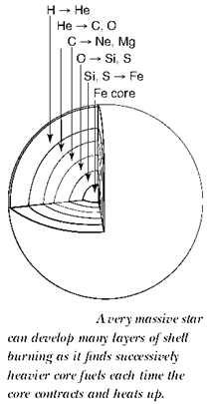***Explain the concept of star death in relation to:***

* ***planetary nebula***
* ***supernovae***
* ***white dwarfs***
* ***neutron stars/pulsars***
* ***black holes***
* Star death occurs when the fusion of elements in the core of the star ceases and the outward pressure of radiation is insufficient to prevent the gravitational collapse of the star. The processes that occur, and the nature of the object that remains, depend on the mass of the star.

*Planetary nebulae*

* If the original mass of the star is less than about 5 solar masses, after leaving the Main Sequence, the star goes through some time as a Red Giant. It starts by burning helium to carbon, and may develop an “onion-skin” structure of different fusion reactions in successive shells (as shown in the diagram on the right).
* Thus, in a dying red giant, instability in the shells causes sudden outbursts of energy, known as ‘thermal pulses’. These outbursts, in conjunction with strong stellar winds, have the effect of progressively blowing away an outer layer of the star. This forms a hollow sphere of gas and dust surrounding the dying core. This is called a **planetary nebula**.

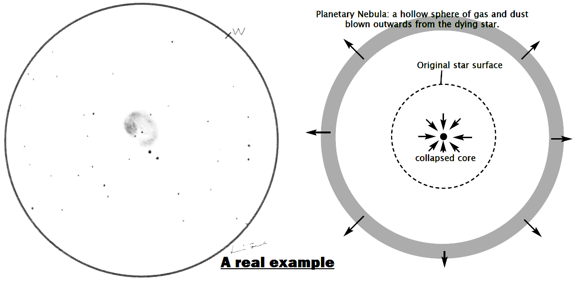

*White Dwarfs*

* The collapsed core at the centre of planetary nebula then becomes what is known as a white dwarf.
* 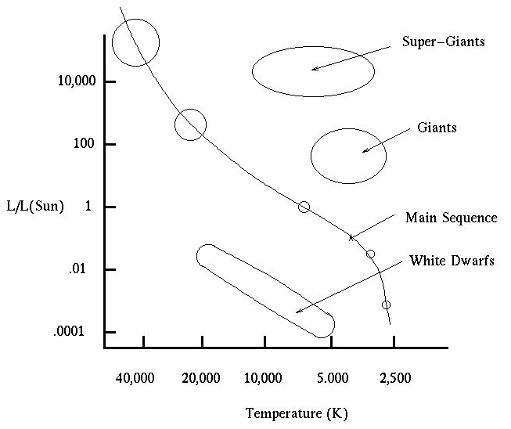Without any remaining ‘fuel’ for nuclear fusion reactions, the core collapses under the force of gravity to form a dense lump of *dengenerate matter*.
  + Degenerate matter is matter where the atoms themselves are compressed into a smaller volume by squashing the electron orbits closer to the atomic nuclei.
* A star the size of the Sun can end up compressed down to a white dwarf that is the size of the Earth. Yet the density of this white dwarf can be as large as one tonne per cm3.
* Anyway, nuclear fusion has ceased in a white dwarf, but this star remnant possesses a lot of residual heat, so its surface temperature may be around 10 000 K. However, being very small, its *total luminosity is quite low*. As a result, on the H-R diagram, white dwarfs occupy a space quite low down, but well left of the main sequence. Hence, this area is known as the white dwarf region, as shown in the diagram on the right.
  + In fact, the typical absolute magnitude of a white dwarf is between +15 and +11.
* Over millions of years, a white dwarf will radiate away its residual heat, gradually cooling and disappearing from our view…
* Note – But why doesn’t a white dwarf collapse further and further, since there’s nothing to oppose the inwards force of gravity? Well, the force opposing further gravitational collapse is what is called ‘electron degeneracy pressure’. This results from a quantum effect, where closely spaced electrons are prevented from being on the same energy level. And this provides the resistive force that prevents further collapse. However, electron degeneracy pressure can only balance out the force of gravity to a certain extent, and that is why white dwarfs have a maximum mass of 1.4 solar masses.

*Supernovae*

* If the star’s original mass is greater than about 5 times the mass of our Sun, the star would have definitely developed an “onionskin” layer structure with some heavy elements in the core (similar to that shown in the diagram on the previous page).
* When the core ceases nuclear fusion (usually at iron), the core suddenly collapses under gravity and rapidly implodes upon itself. The outer layers suddenly have nothing holding them out, so they fall inwards at an enormous speed. These outer layers still contain ‘fuel’ for fusion, and this fuel ignites in a cataclysmic detonation – a supernova explosion.
* There are two main results:
  + large amounts of heavy elements (up to uranium) are able to be formed in a rapid burst
  + the outer layers of the star are blown outwards in a fireball that briefly outshines a million stars; it continues to expand outwards as a cloud of debris for thousands of years to come
* Here’s an interesting fact – “The energy released in a supernova explosion can be greater than all the energy released by the Sun in 10 years. Sometimes, the total energy released can rival that of a galaxy.”
* Now, what happens to the core after the supernova explosion depends on the mass of the star. The star may become a neutron star ( / pulsar) or a black hole.

*Neutron Stars / Pulsars*

* If the remaining core from a supernova explosion is more than 1.4 solar masses but less than 3 solar masses, it forms a neutron star. What happens is that matter is crushed to such an extent that electrons and protons are forced together to form a sea of neutrons, and it is then neutron degeneracy which halts any further collapse. As a result, the core is now a neutron star.
* A neutron star is an *extremely dense*, hot star which rotates even more rapidly, due to conservation of angular momentum as the star shrinks to a significantly small fraction of its initial size. Neutron stars also have a very powerful magnetic field that emits beams of EM radiation, which sweep across space as the neutron star rapidly rotates.
  + Neutron stars are so dense that they usually have an average diameter for 30 kilometres.
* But what is the difference between a neutron star and a pulsar? Well, a neutron star uses up a lot of its rotational kinetic energy, moving its magnetic field around, and so it gradually slows down. When it slows down enough, it no longer radiates very much energy, and so it is no longer considered a pulsar. At this point, it is only a neutron star.

*Black Holes*

* If the remaining core from a supernova explosion is more than 3 solar masses, absolutely nothing can stop the core’s gravitational collapse. Matter is crushed down to a point of infinite density. In fact, the gravity at this point is so great that nothing, including light, can escape from it within a certain radius. This is a black hole!

Here is a summary:

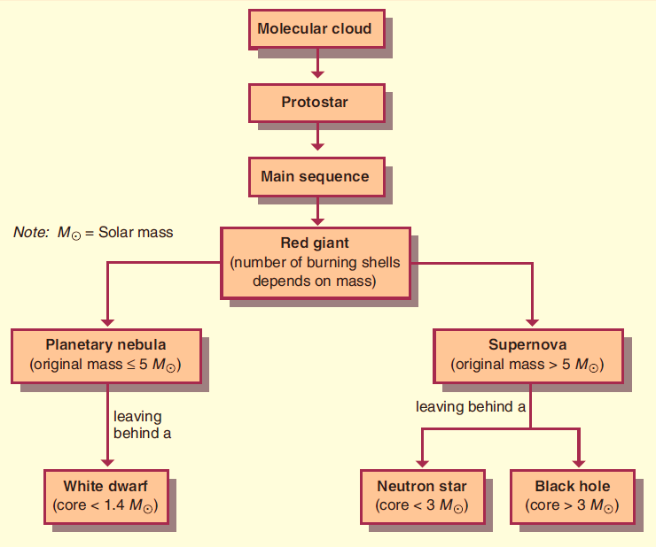

***Present information by plotting Hertzsprung-Russell diagrams for: nearby or brightest stars, stars in a young open cluster, stars in a globular cluster***

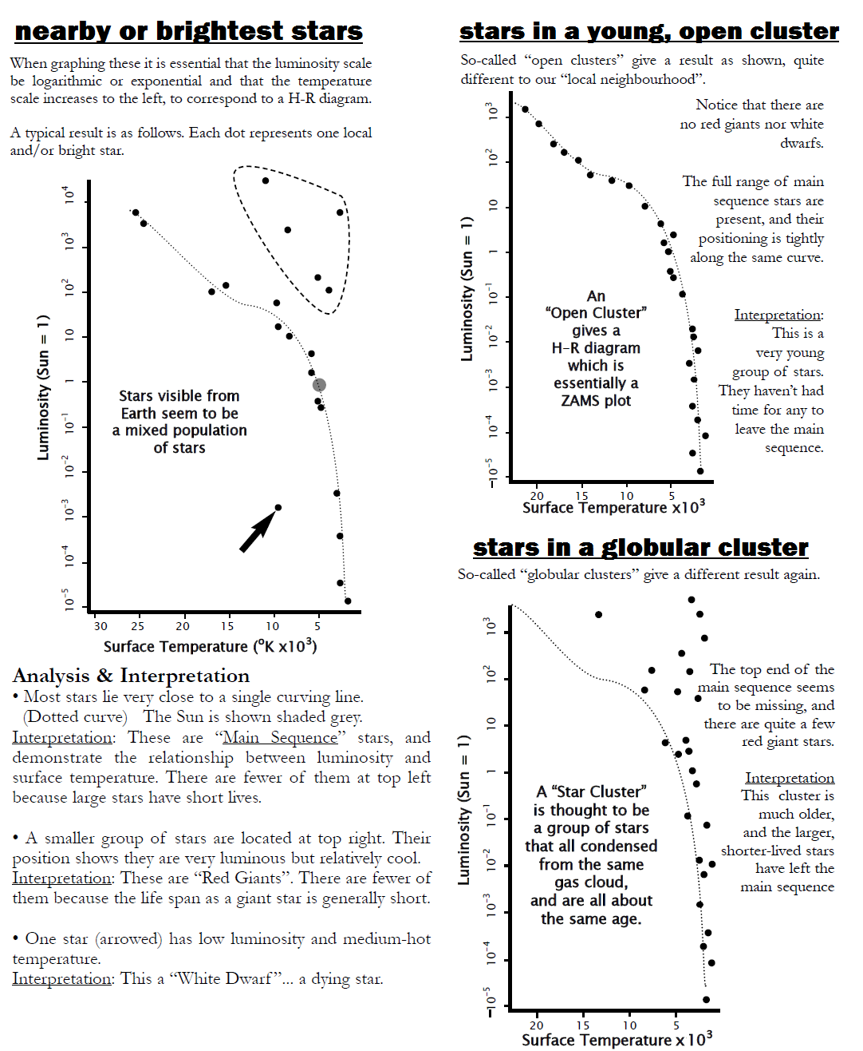

***Analyse information from a H-R diagram and use available evidence to determine the characteristics of a star and its evolutionary stage***

Sample Analysis (from CSU)

* **Star A** is low and to the right of the main sequence, therefore it is a protostar, at a very early stage of its life, and heading for the main sequence. It is very cool, but is nearly as luminous as the sun, therefore it is very large.
* **Star B** is on the main sequence, so it has begun to produce energy by fusion of hydrogen into helium. Its low surface temperature shows it to be a red star, while its low luminosity, and position at the bottom of the main sequence, show it to be a dwarf. As a low-mass star, it will consume its fuel very slowly and spend a very long time on the main sequence.
* 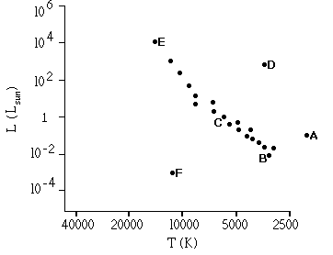**Star C** is on the main sequence and is steadily converting hydrogen to helium by fusion. Its surface temperature is approximately 6000 K (remember that the scales are logarithmic), so it is a yellow star like the sun. It is also approximately as luminous as the sun, therefore it must be of similar mass to the sun.
* **Star D** is in the region of red giant stars. It is relatively cool, but about 1000 times as luminous as the sun, therefore it must be very large. It has consumed most of its fuel and is near the end of its life.
* **Star E** is very hot and very luminous, about 10 000 times as luminous as the sun, but it is on the main sequence. It must therefore be a very young star, as such a star consumes its fuel quickly and would not stay on the main sequence very long. It is very massive and will have a short, violent life, ending in a supernova.
* **Star F** is a hot white star, but from its low luminosity, and its position on the H-R diagram, we can see that it is very small. It is a white dwarf and is at the end of its life.

***Present information by plotting on a H-R diagram the pathways of stars of 1, 5 and 10 solar masses during their life cycle***

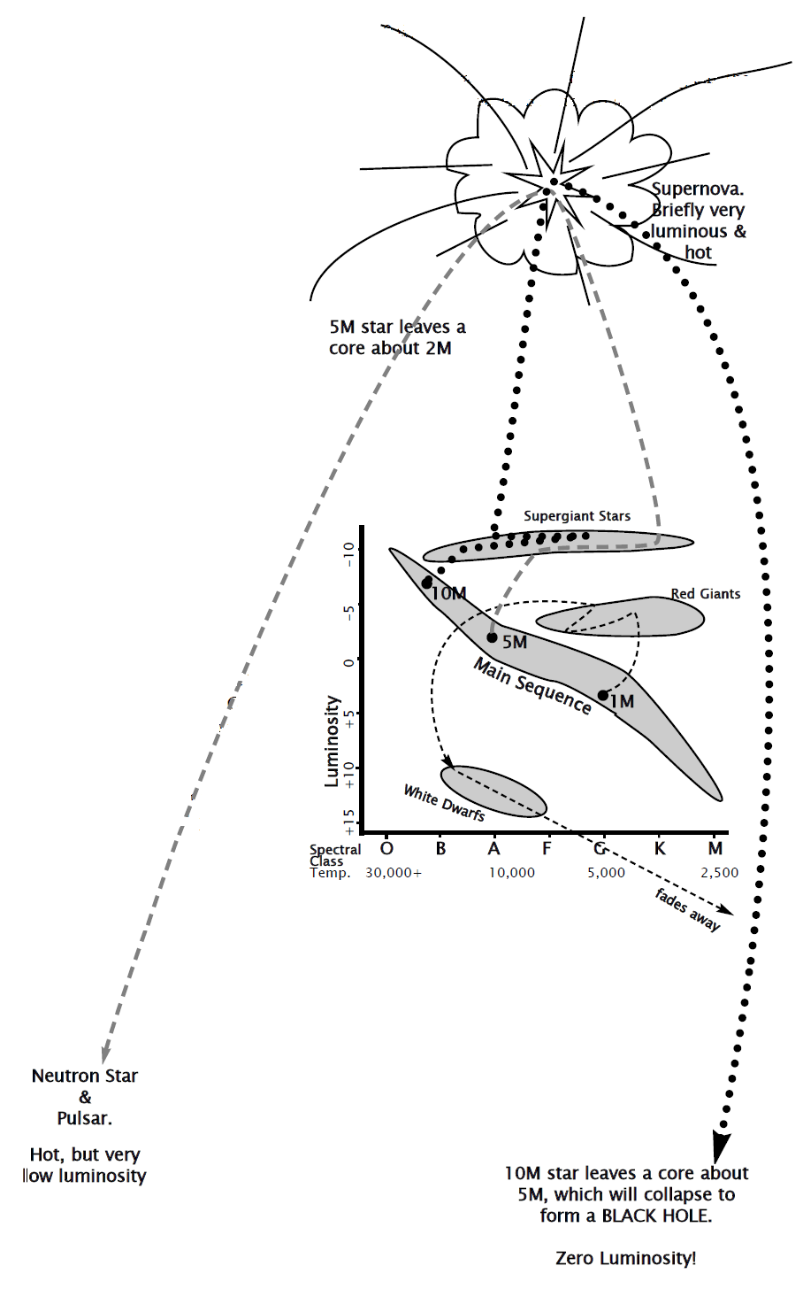

**YAY! End of Notes :D**

